1. It’s possible to change the variable’s value during debugging.
2. 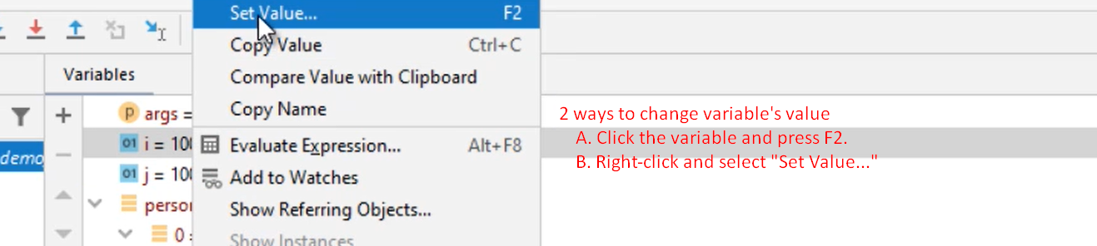
3. 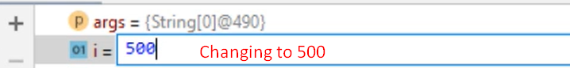
4. 